# Voice Control Sunroof Function

## Functional Description

The Voice Control Sunroof allows driver to control Sunroof through voice command by activating voice control system by typical wake-up world.

## Interfaces

### Interface Context Diagram (I/O Block Diagram)

1. **Voice Control Sunroof Display Function Context Diagram**

Voice command

APIMSunroofControl,

APIMSunshadeControl

### Inputs

* INTERNAL:
* Operational_Mode
* Driver’s Commands
* **Sunroof control**

|  |  |
| --- | --- |
| **Signal Name** | **Description** |
| Natural language: Sunroof control | “打开天窗” ： 天窗全开  “关闭天窗”：天窗全关  “我要通风”：天窗开启到tilt up模式  “开一点天窗”： 天窗到舒服模式(半开天窗) |

* **Sunshade control** 对于1piece天窗不适用

|  |  |
| --- | --- |
| **Signal Name** | **Description** |
| Natural language: Sunroof shade control | “打开遮阳帘” ： 遮阳帘全开  “关闭遮阳帘”：遮阳帘全关  “开一点遮阳帘”： 遮阳帘开一半 |

* **Scene control**

|  |  |
| --- | --- |
| **Signal Name** | **Description** |
| Natural language: scene control | “我要看星星” ： 遮阳帘全开（对于1piece天窗不适用），天窗全开  “我觉得有点闷”： 天窗起翘 |

1. Outside_Air_Temp_Stat Signal

### Outputs

LIN message to Sunroof controller

## Function/Performance

### Operational Modes

|  |  |
| --- | --- |
| **Mode** | **Differentiating Vehicle Conditions** |
| Sleep Mode | Voice control OFF |
| Limited Mode | Voice control OFF |
| Normal Mode | Voice control ON/OFF |
| Crank Mode | Voice control OFF |

### Voltage Levels

Refer to SYNT+ module

### Human-Machine Interface

#### Visual

#### Indicator Graphics / Display Format

##### Indicator Color Coordinates

None

##### Indicator Characteristics

Refer to Message Center X display text message list.

None.

### System Accuracy

none

### Operation: Performance and Functional

#### Subsystem Algorithm Flowchart / State Diagram

1. LINutine

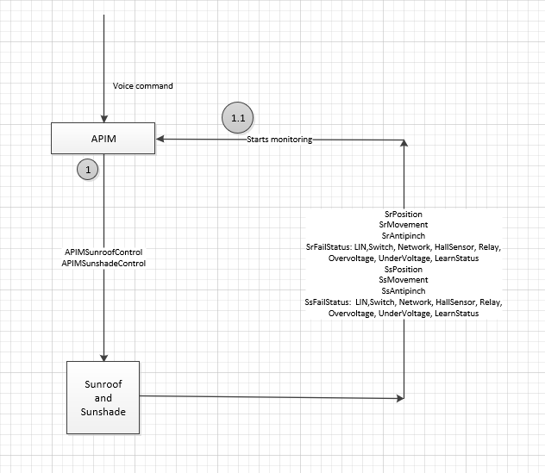

#### Message Center Msg

Current is NA

## Error Handling

### Missing Message Strategy

LIN communication error

### Invalid Message Strategy

LIN message is invalid

## Diagnostics

### Self Test

None

### Engineering Test Mode

### Part II Performance

**DID DExx**

|  |  |  |  |  |  |  |  |  |  |
| --- | --- | --- | --- | --- | --- | --- | --- | --- | --- |
| **Block**  **Num** | **Block Description** | **Size (bits)** | **State: Description** | **"0"** | **"1"** | **"2"** | **"3"** | **Default** | **Comments/**  **Information** |
| $00 | Voice control Sunroof enable | 2 | Sunroof type | No Sunroof | 1 piece Sunroof | 2 pieces Sunroof | reserved | No Sunroof | When Enabled through config |

## Reference Specification



## Revision History